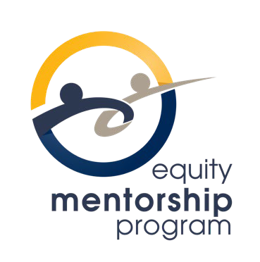
Equity Mentorship Program 2026-2028 Statement of Interest: Mentor
Applications can be submitted to Jenny Chen (jenny.chen@osstf.ca) Deadline - 4:00 p.m. on Wednesday, October 28, 2026.

Personal Information
Name:
District:
Bargaining Unit:
Position/Role:

Contact information
Address:
Email:
Phone:

I have confirmed with my Bargaining Unit President that I am able to access time
No release days from my employer (costs charged to the OSSTF/FEESO Equity Mentorship Program).

The 2026-2028 cohort of the Equity Mentorship Program will focus on member representation, contract maintenance, negotiations, and health and safety.

Question 1: Explain why you would be an ideal mentor for this cohort of the Equity Mentorship Program. Describe your experience in member advocacy, representation, and protective services. Include specific examples of your involvement in areas such as collective agreement interpretation, grievances, health and safety, negotiations, pay equity, return to work, LTD, and/or member support.

Equity Mentorship Program 2026-2028 Statement of Interest: Mentor

Question 2: Explain how you have applied your knowledge and skills to navigate complex union
Situations. Use examples from your experience in areas such as collective agreement interpretation, grievances, health and safety, negotiations, pay equity, return to work, LTD, and/or member support.

Question 3: How would you use your experience, knowledge, and skills to help a mentee develop their confidence, judgment, and ability to represent and support members?

